**6) If a positively (right) skewed distribution has a median of 50, which of the following statement is true?**

A) Mean is greater than 50

B) Mean is less than 50

C) Mode is less than 50

D) Mode is greater than 50

E) Both A and C

F) Both B and D

Answer:

Below are the distributions for Negatively, Positively and no skewed curves.

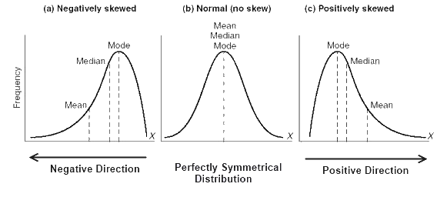

As we can see for a positively skewed curve, Mode<Median<Mean. So if median is 50, mean would be more than 50 and mode will be less than 50.